**Home** Services Offered USP Picture Gallery Why Mad People Contact us

MAD

Our MADDENING Jingle!

GET MAD

Or you’ll be Sad

There’ll be no shingles

What with our tingles

You’ll feel glad

That you got MAD!

Yea, Yea GET MAD

You curse your boss

And send him for a toss

Don’t worry don’t feel bad

For you are here to GET MAD!

When you’re with us

Your toes will be cuddled

And your head will be muddled

But you’ll feel fine

Bright as sunshine

For you’ve never had

An experience to GET MAD

Yea, Yea GET MAD

For that’s the Fad

By Gad! You’ll never feel sad

Through an experience you never had.

Refrain Get MAD, Get MAD… go on GET MAD! ☺

Masseurs at Doorstep

“The time to relax is when you don't have time for it."- Sydney J. Harris

Pioneers in the concept of bringing SPA @ Workplace

**Concept**

The aim of The MAD Team is to visit your corporate doorstep and provide with ultimate relaxation and help bring down the stress levels of your employees. In short we will come and create a mini spa @ workplace, give you the experience of one of the most luxurious spas around, right there within your office environment.

**About US**

A team of dynamic people who are out with the aim of giving you relaxation of body and mind in a super luxurious environment without disturbing your office set up. Our trained therapist will pamper you and will adapt to a wide variety of body types and sensitivities to pressure.

Home  **Services Offered** USP Picture Gallery Why Mad People Contact us

**Therapies per Employee**

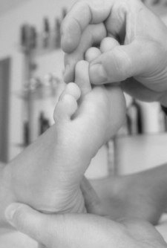20 Minute Foot Reflexology and Thai Massage

20 Minute Shoulder-Neck Massage and Hand Massage

30 Minute Foot, Shoulder-Neck and Hand Massage

30 Minute Head, Shoulder-Neck and Hand Massage

**Other Services**

Yoga

Physiotherapy

Dietitians

**Applicability of MAD Services**

|  |  |  |
| --- | --- | --- |
| * All Corporates big or small are welcome to experience MAD services within their office premises. * Motivational activities for your employees, announce it as the “distressing week @ workplace” and we’ll be happy to help! * Expecting some important delegation/partners to fly in from Germany, Canada, The USA? Just call us and we’ll sweep them off their feet! * Having some local conference/party/seminar? Add some spice to it, let the team have something to look forward to during their hi-tea breaks! * Ladies day out in Embassies? Call us and we will take care of distressing your group! |  |  |
|  | | |

Home Services Offered **USP** Picture Gallery Why Mad People Contact us

Our USP lies in executive perfect massages within your office premises. The only aim of our existence is to deliver de-stressing solutions in your own habitat without disturbing the work environment.

We come with a team of highly skilled and efficient people, create a beautiful spa set up …… NOT YET COMPLETE WILL ADD MORE MATTER… SWA..

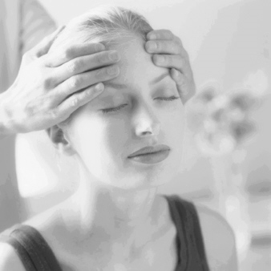

Home Services Offered **USP** Picture Gallery Why Mad People Contact us